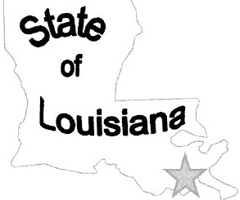
Grand Isle Port Commission
John Bel Edward.a - Governor
Commissioners: Bob Sevin-Preaident, Ambrose Beason-Vice President,
Perry Cbigbimla-Sec::retary/Treasurer, Terrill Pizani, and
Ernie BalJafl'\
Weldon Danos-Emm.tiveDh-ecm

Thursday, March 17, 2022

Meeting opened at noon by Commissioner Bob Sevin at the Grand Isle Multiplex Building located at 3101 Louisiana Highway 1. Commissioners present were Bob Sevin, Ambrose Besson, Terrill Pizani and Ernie Ballard. Commissioner Perry Chighizola was absent.

A motion was made by Commissioner Ballard, seconded by Commissioner Pizani and unanimously agreed to approve the minutes of the meeting held on February 10, 2022 as read.

A motion was made by Commissioner Pizani, seconded by Commissioner Ballard, and unanimously agreed to approve the financial report and pay all invoices associated with operating the port commission.

Mr. Danos read the engineering report. It stated that we are still waiting on FEMA to move forward on repairing the Commercial Dock. Worked with damages from Hurricane IDA to compile a list of damages. Submitted two Capital Outlay Projects for the port. Will monitor the session to see if the projects stay on the list.

Executive Director Weldon Danos addressed the commissioners and stated that are continuing to receive money for the boats docked at the Commercial Dock. The La Dried Shrimp Company has started repairs. Working on getting quotes to repair office building on Louisiana Highway 1. The Wildlife and Fisheries as offered us a office as long as needed. Four Oyster Farmers has received a grand of the Sea Grant Program. Attended the PAL meetings and was appointed to Secretary on the Executive Committee. Terms begins July 1, 2022 for one year. The shellevator was discussed. A motion was made by Commissioner Ballard, seconded by Commissioner Pizani, and unanimously agreed to deny the location as not feasible for the shellevator. The Hurricane Hole is marking the Caminada Pass using the buoys and cement barrels with chains holding the markers. The port has come buoys that can be donated and can be used for the pass. A motion was made by Commissioner Ballard, seconded by Commissioner Pizani, and unanimously agreed to donate the eight buoys that the port has to be used for the Caminada Pass.

A motion was made by Commissioner Pizani, seconded by Commissioner Besson, and unanimously agreed to go into executive session to discuss personal matters at 12:41 p.m.

A motion was made by Commissioner Besson, seconded by Commissioner Ballard, and unanimously agreed to reconvene the meeting at 12:57 p.m.

A motion was made by Commissioner Ballard, seconded by Commissioner Besson, and unanimously agreed to adjourn the meeting at 12:59 p.m.

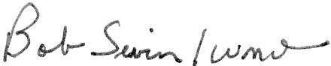

Bob Sevin, Commissioner
Grand Isle Port Commission

P.O. Box 500 Grand Isle, LA 70358
cretaryffreasurer
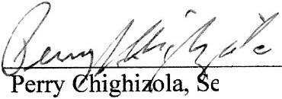Grand Isle Port Commission

(985) 787-2229 www.grandisleport.com

